***cpu :***

# CPU, short for Central Processing Unit, is the basic and important part of a computer and is responsible for processing data and performing all logical and arithmetic operations.I dream of an Intel Core i9-13900K processor. Number of cores: 16 cores. The number of phantom nuclei: 32 nuclei.

# 

***HARD DRIVE :***

# A hard disk is a main data storage unit or device in a computer. It is used to store and retrieve digital information from and on fast spinning disks. It consists of spinning magnetic disks and an electromagnetic pickup that reads and writes to and from the magnetic surface. One of the most important characteristics that distinguish each hard disk from another is its storage capacity and rotational speed.I dream of Toshiba X300 disk drive

***storage :***

A computer data storage unit, often called a storage unit or memory, is a technology consisting of computer components and recording media used to hold digital data. It is an essential component of computer. I dream of

Team Group T-Force Xtreem ARGB DDR4-3600 2 x 8 GB

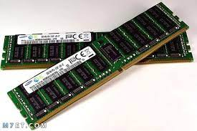

***motherboard :***

A motherboard, also known as the main board and system board, is the central or main printed circuit board in a complex electronic system .I am dreaming of ASRock X299 Taichi motherboard, which is the best choice because it has 128 GB of RAM with an X-series processor and a good graphics card.

